- User name Techie with sudo access
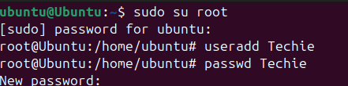
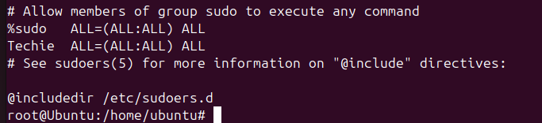
- Home Directory

- New Directory
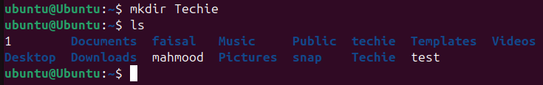
- Contents of a directory
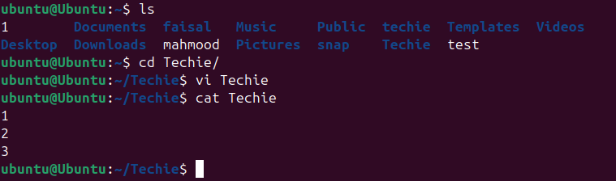
- Change the current Directory
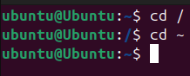
- New Empty File
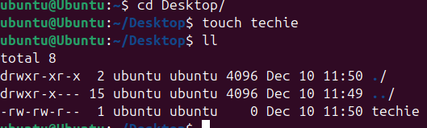
- Contents of the file
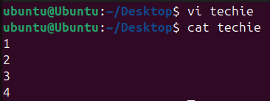
- Copy a file to another location
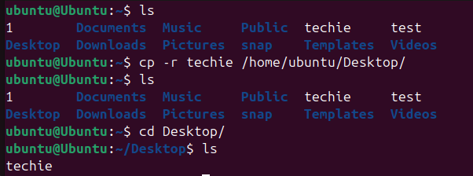
- Move a file to another location
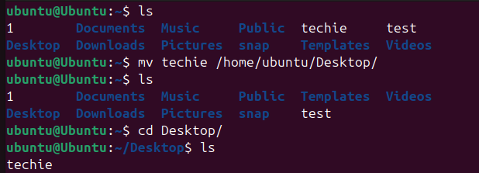
- Rename the file
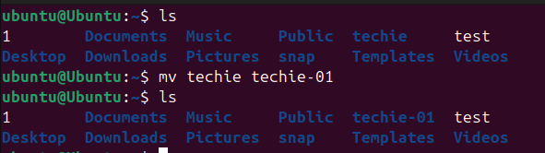
- Delete a file
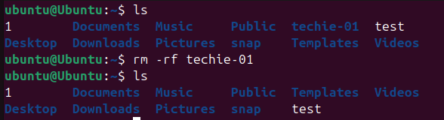
- Grant permission on a file
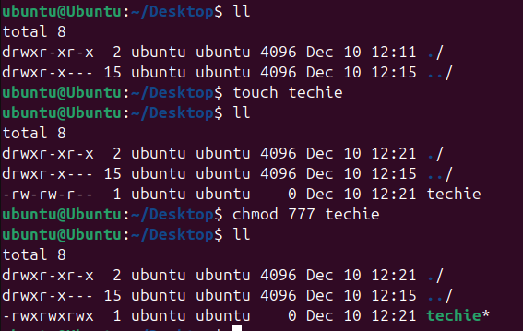
- Current date and time
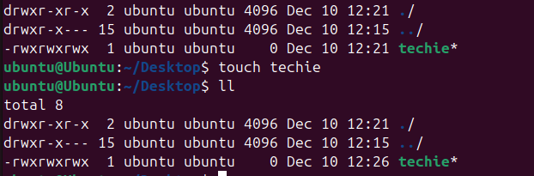
- Check the system uptime
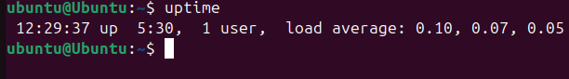
- View the Running processes
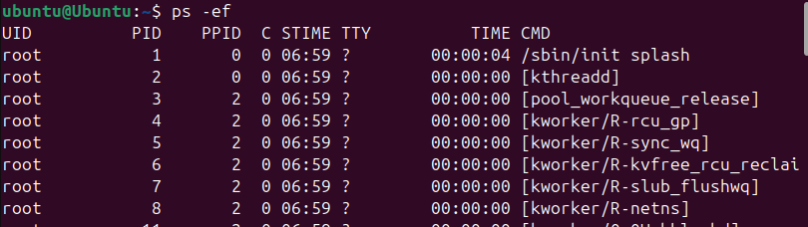
- Kill a running process
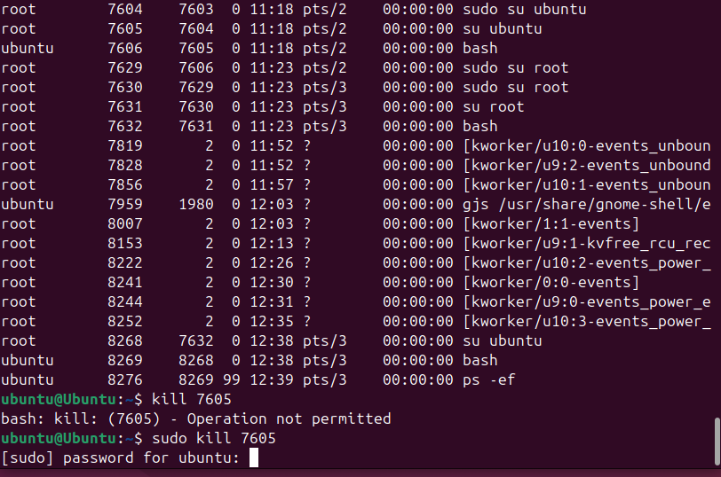
- Install a package
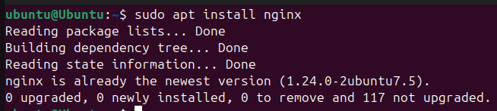
- Update the system package
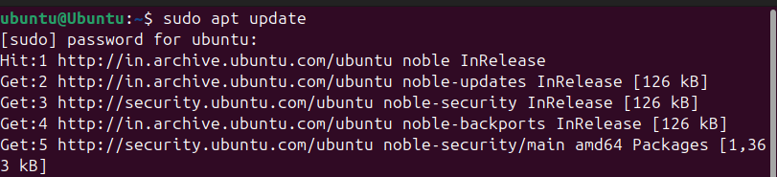
- Create symbolic link
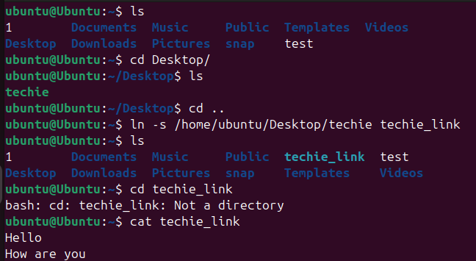
- Search for files using file command
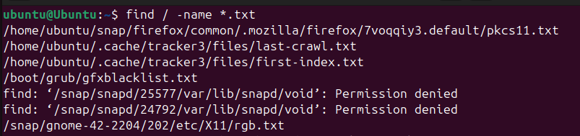
- Compress and decompress files using tar
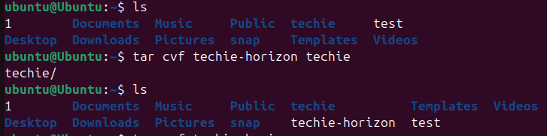
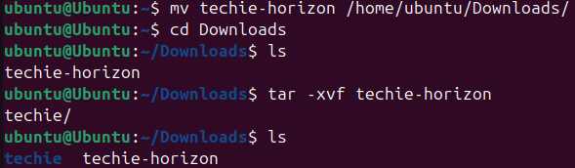
- Monitor system resources
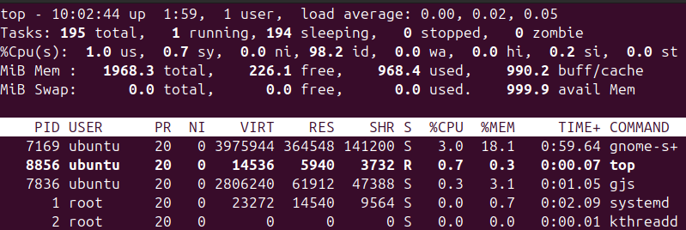
- Create and manage user groups
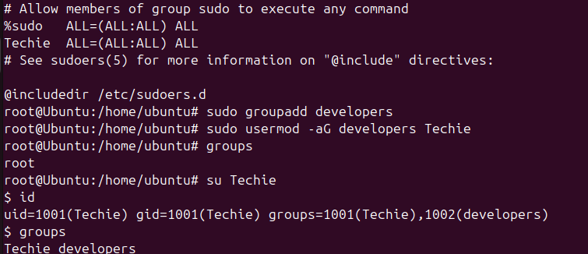
- Setup SSH password less authentication
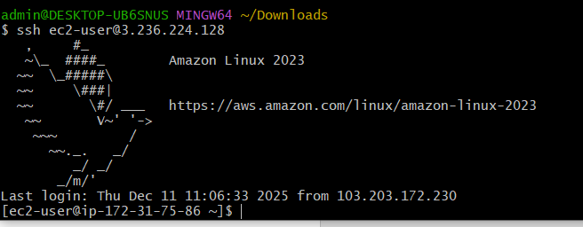
- Monitor log files using tail or grep
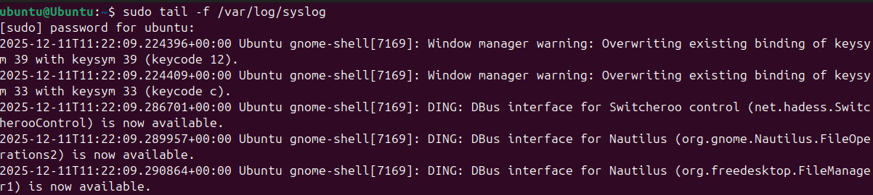
- Setup a webserver (eg – Apache or nginx)
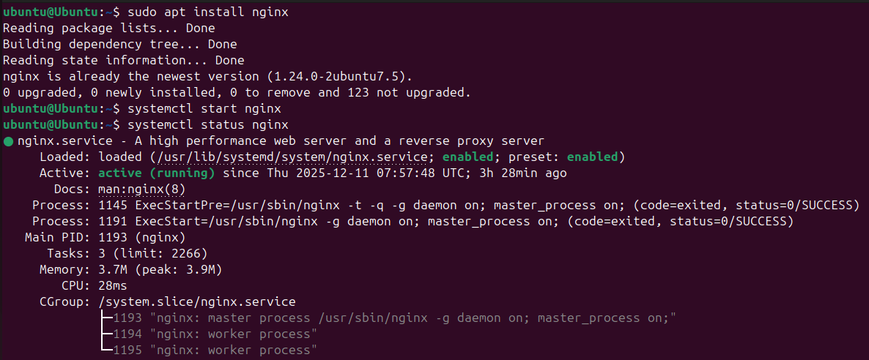
- Configure and secure a MSQL Database
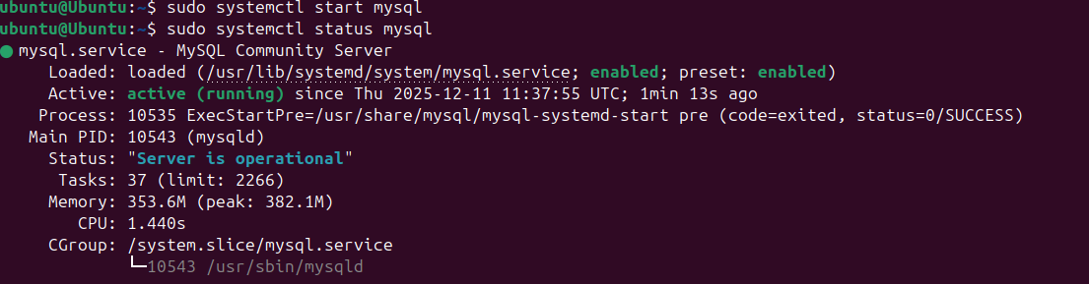
- Set up a application server (eg : Apache Tomcat )
- Create a service file for apache (should execute by using systemctl command)
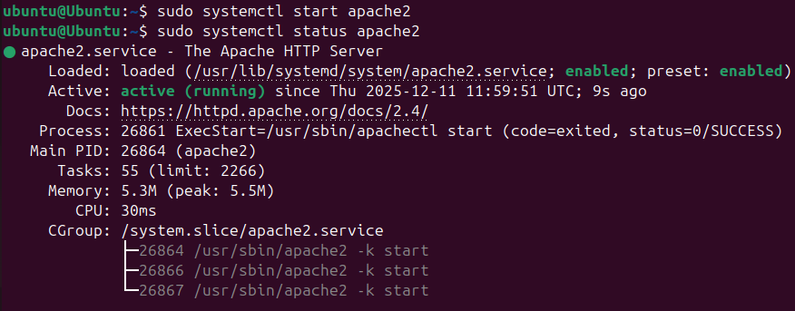
- Print specific columns from a delimited file
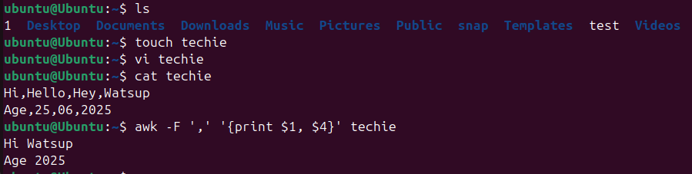
- Filter and print lines based on a specific pattern or condition
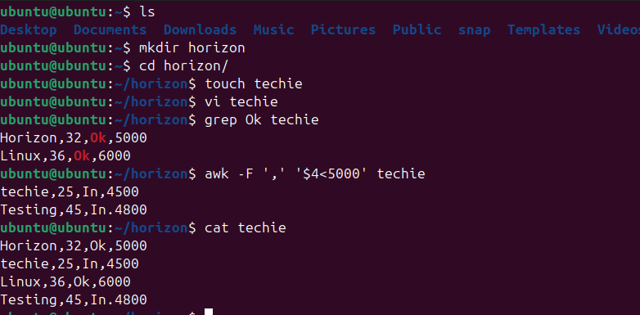
- Calculate and print the average, sum, or other statistics of a column
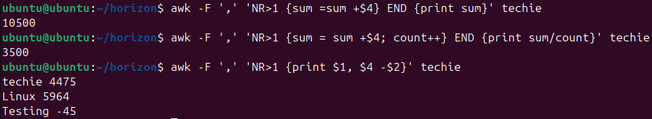
- Perform string manipulation, such as extracting substrings or changing case.
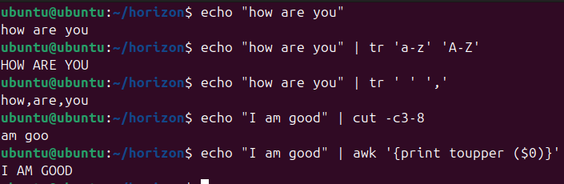
- Count the occurrences of a specific pattern in a file
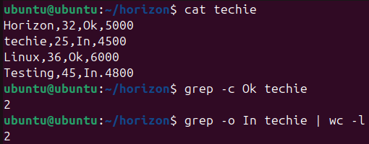
- Sort lines based on a specific field or column
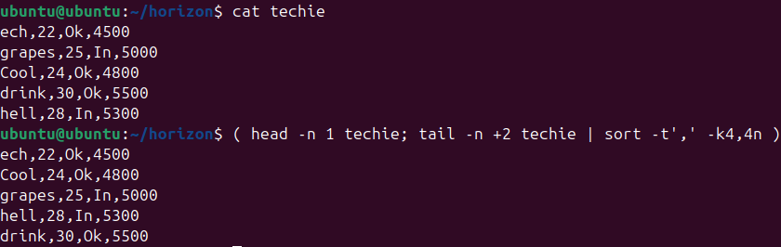
- Merge multiple files based on a common field or column
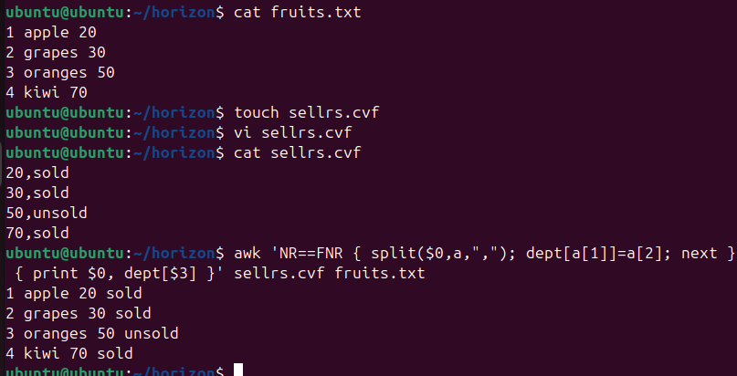
- Substitute text in a file using search and replace
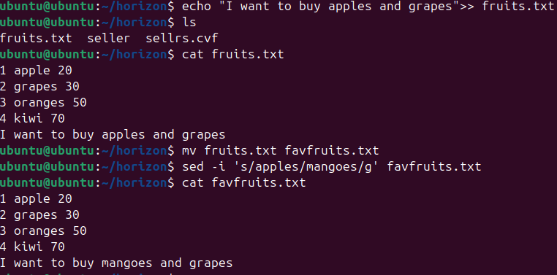
- Delete specific lines based on a pattern or line number
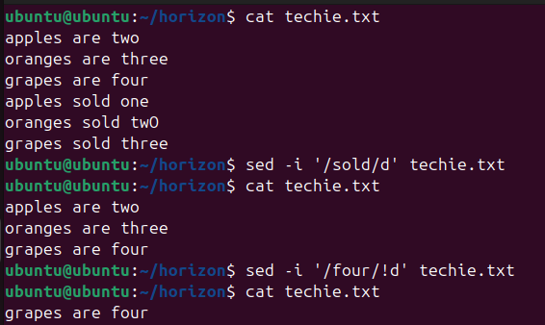
- Append or insert text before or after a specific pattern or line
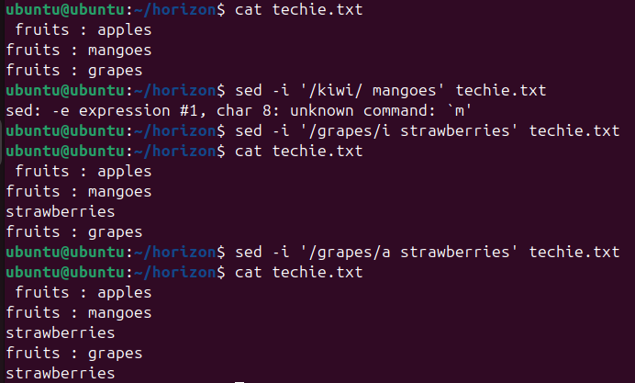
- Print only specific lines from a file
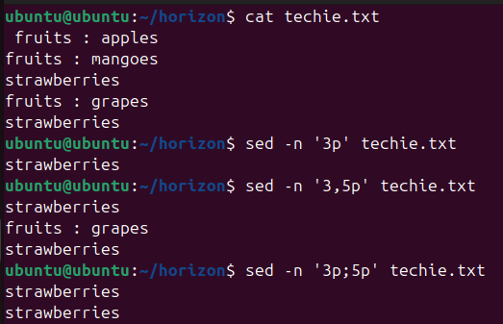
- Copy file from linux to windows machine
- 5 use cases for AWK and 5 use cases for sed.
- awk -F ',' 'NR>1 {sum = sum + $n} END {print sum}' filename – for adding content in a file
- ps -ef | awk '{print $2}' - gives pid column in processes,
- awk -F ',' 'NR>1 {sum = sum + $4; count++} END {print sum/count}' filename - an example for taking a average in a file.
- awk -F ',' 'NR>1 {print $1, $4 - $2}' filename - an example for subtracting ( NR>1 means to ignore the first line, use it if the file contains header)
- sed -i '/keyword/d' filename - to delete lines with the specific keyword.
- sed -i '/keyword/!d' filename - to delete every line except the ones with the specific keyword.
- sed -n '3p' filename - to print the third line.
- sed -n '2,4p' filename - to print 2-4 line.
- sed -n '/keyword/p' filename - print lines that match a pattern.

